Muhammad Anas
25k-0899 Fast university
OOp Lab task 8

CLASSTASKS

Task1:

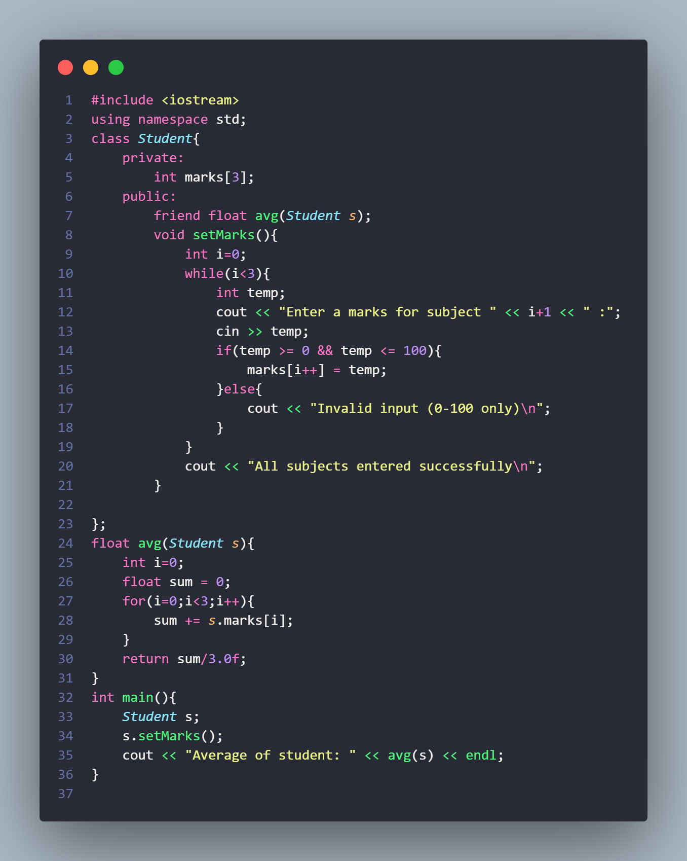

Output:

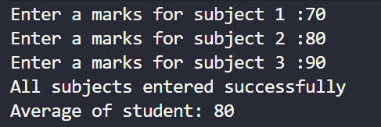

Task 2:
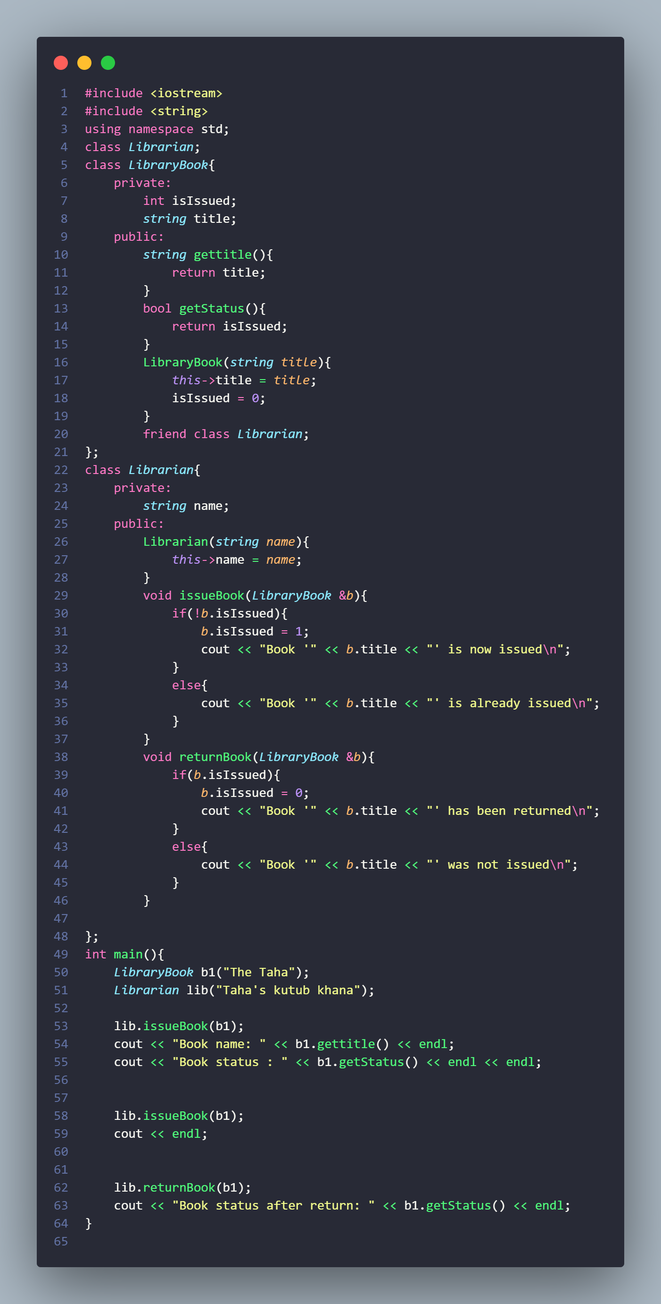

Output:

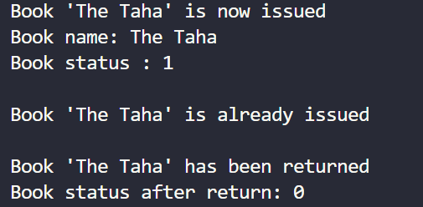

  - Task 3:
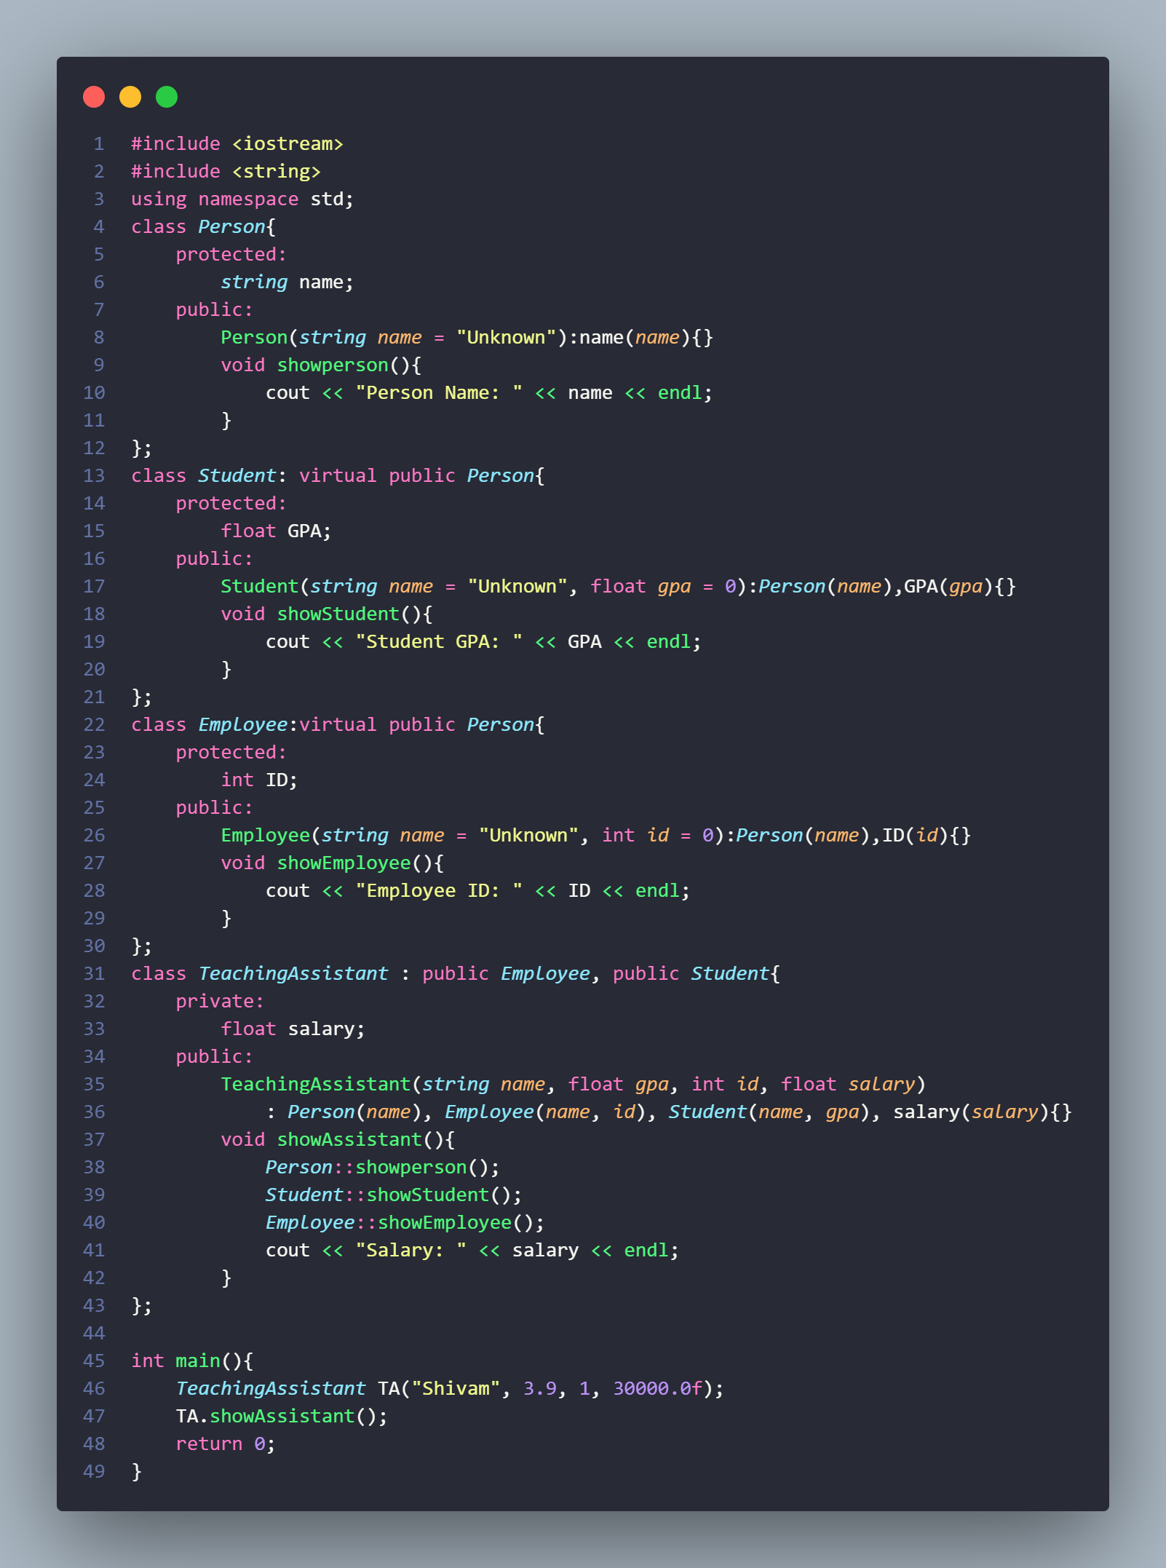
Ambiguity Error:
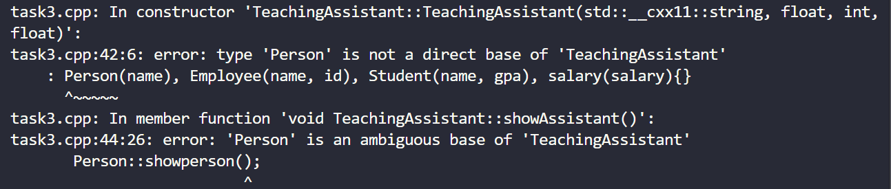

Output:

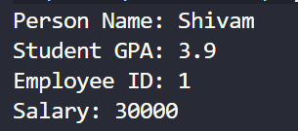

LABTASKS:

TASK1:
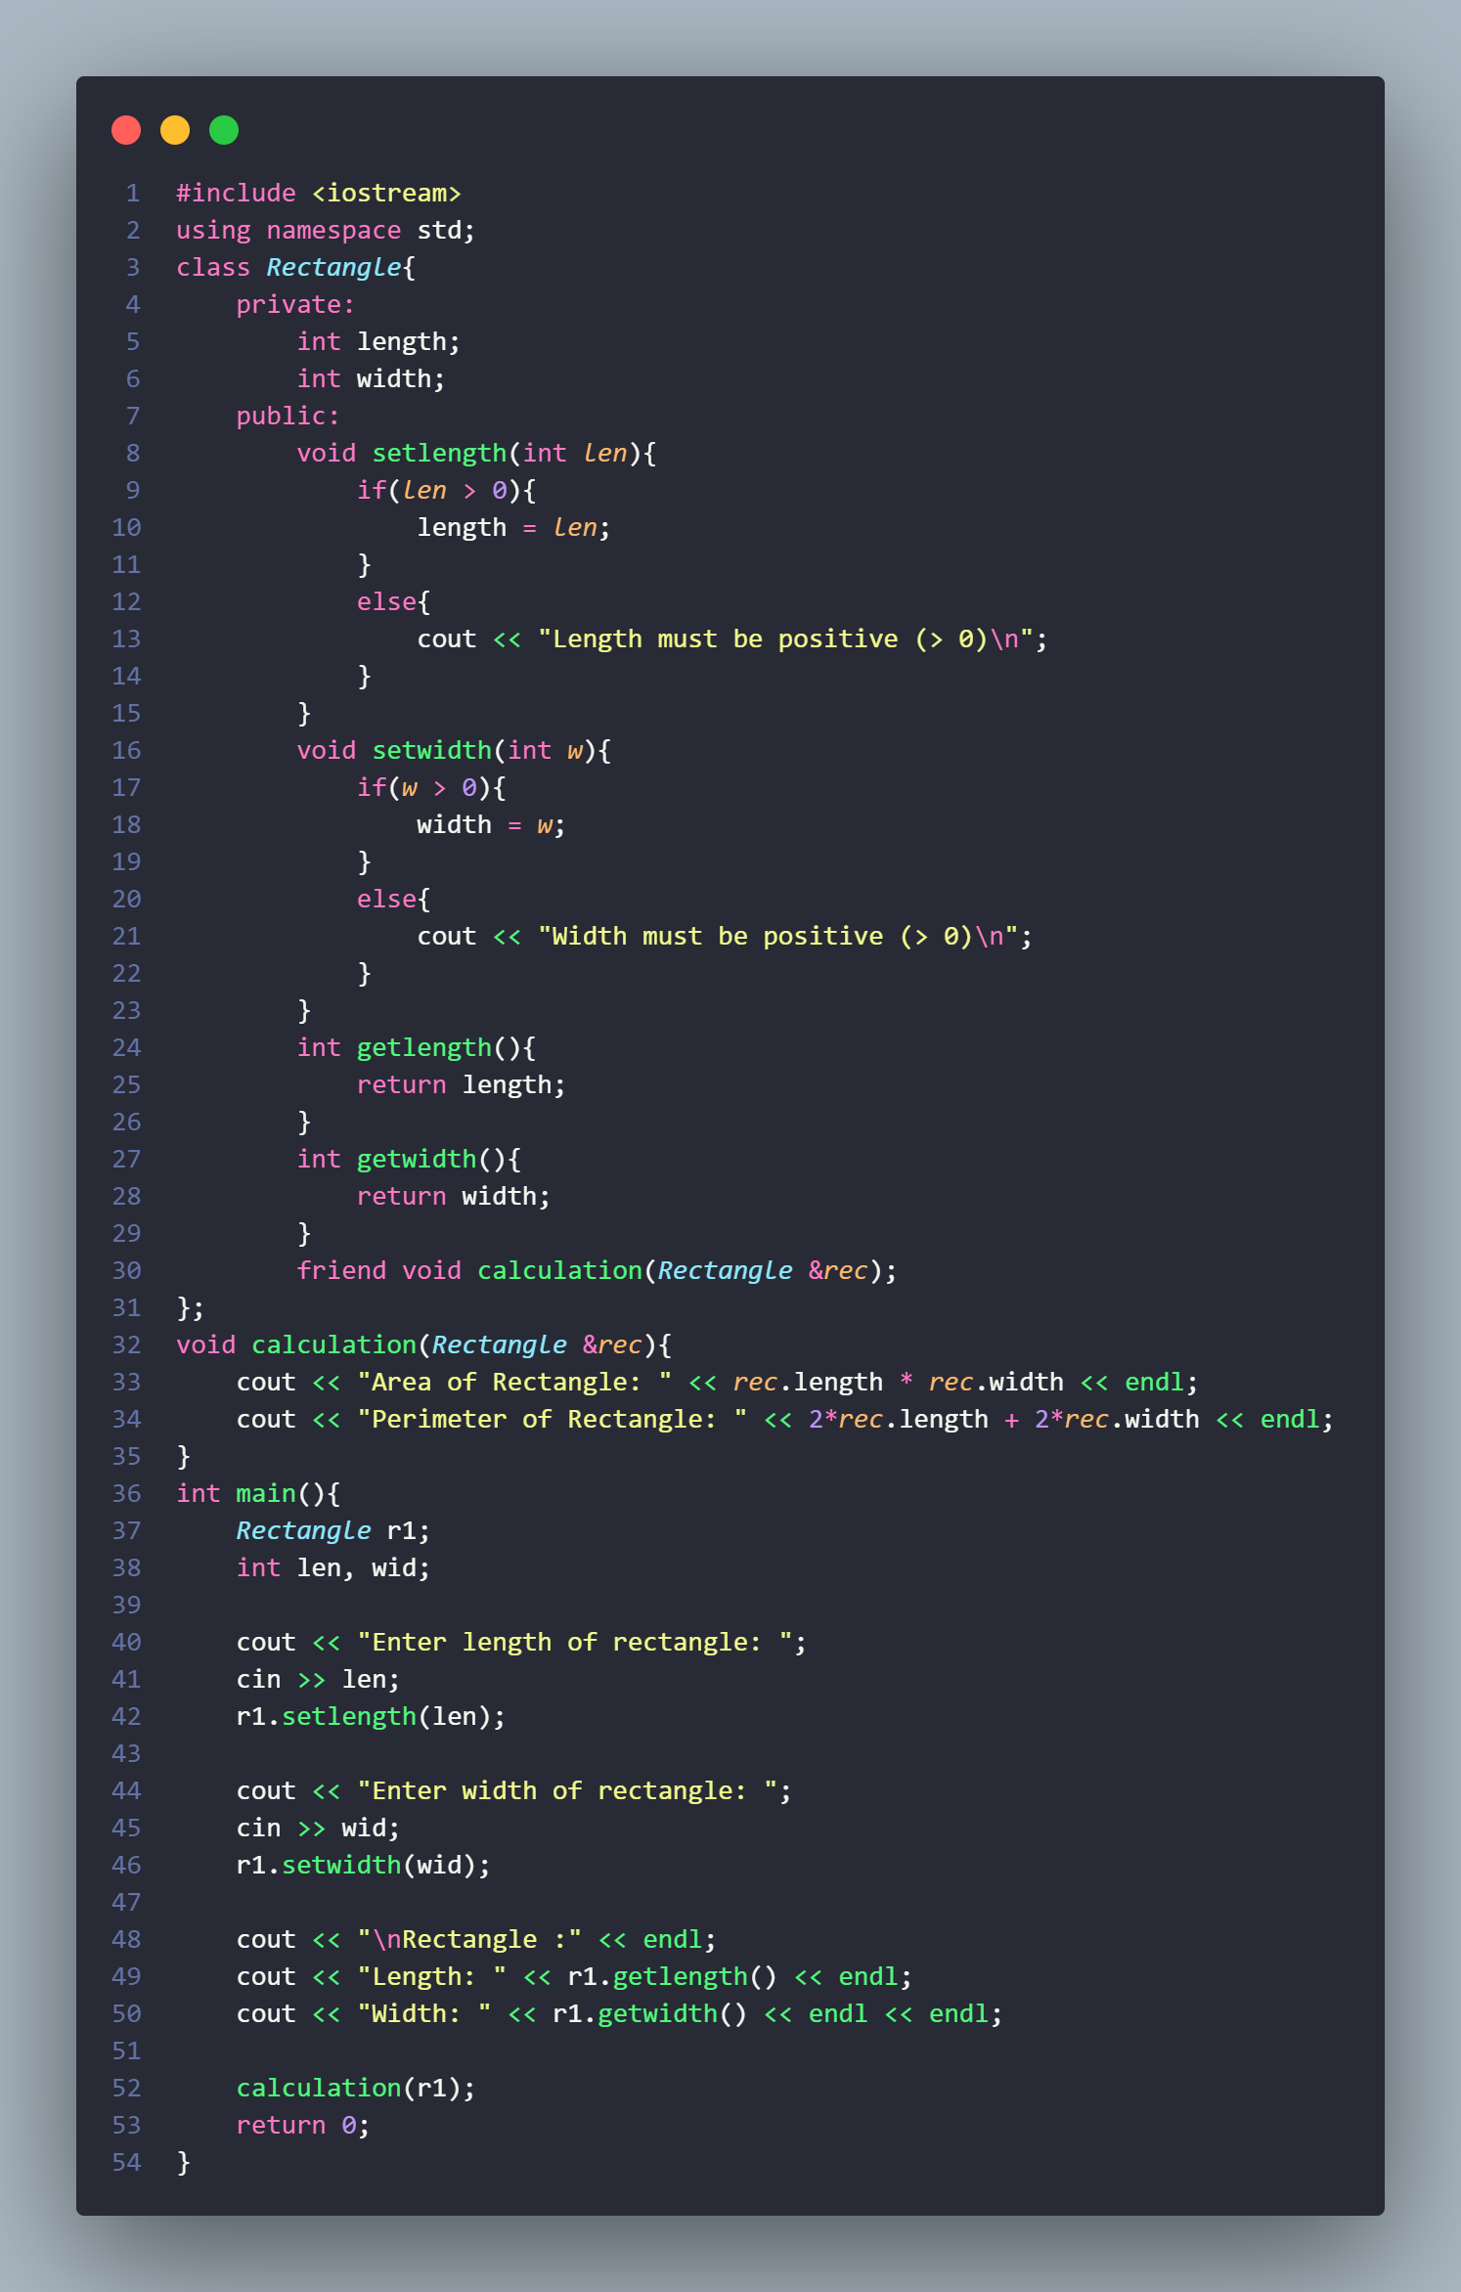

Output:
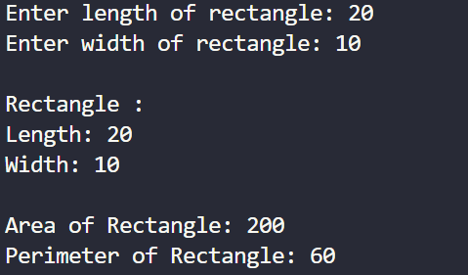

TASK2:

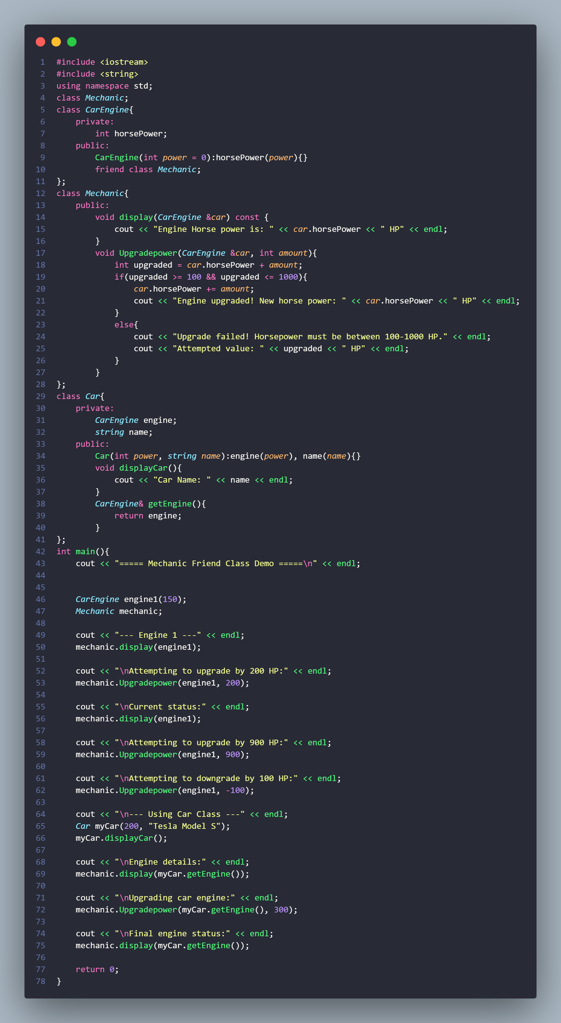

Output:

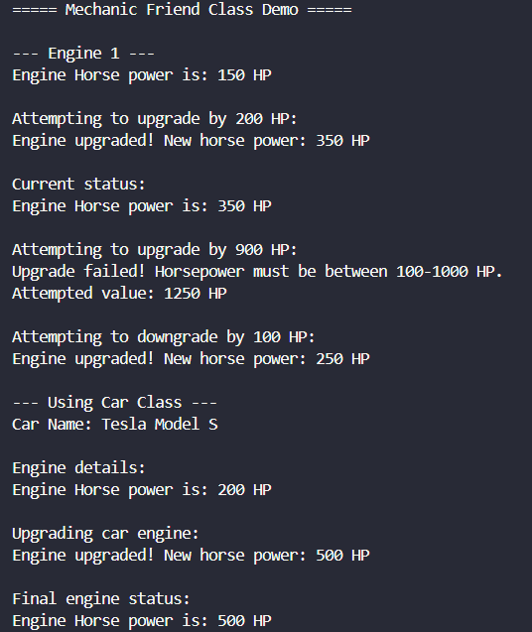

TASK3:

#include <iostream>
#include <string>
using namespace std;

class Person {
private:
int ID;
string name;
public:
Person(int id = 0, string n = "Unknown") : ID(id), name(n) {}

int getID() const {
return ID;
}

string getName() const {
return name;
}

void setPerson(int id, string n) {
ID = id;
name = n;
}

void showPerson() const {
cout << "ID: " << ID << ", Name: " << name << endl;
}
};

class Student : virtual public Person {
protected:
float GPA;
public:
Student(int id = 0, string n = "Unknown", float g = 0.0)
: Person(id, n), GPA(g) {}

float getGPA() const {
return GPA;
}

void setGPA(float g) {
if(g >= 0.0 && g <= 4.0) {
GPA = g;
} else {
cout << "Invalid GPA. Must be between 0.0 and 4.0" << endl;
}
}

void showStudent() const {
cout << "Student - ";
showPerson();
cout << "GPA: " << GPA << endl;
}
};

class Employee : virtual public Person {
protected:
float salary;
public:
Employee(int id = 0, string n = "Unknown", float s = 0.0)
: Person(id, n), salary(s) {}

float getSalary() const {
return salary;
}

void setSalary(float s) {
if(s >= 0) {
salary = s;
} else {
cout << "Invalid salary. Must be non-negative." << endl;
}
}

void showEmployee() const {
cout << "Employee - ";
showPerson();
cout << "Salary: $" << salary << endl;
}
};

class TeachingAssistant : public Student, public Employee {
private:
float bonus;
public:
TeachingAssistant(int id = 0, string n = "Unknown", float g = 0.0,
float s = 0.0, float b = 0.0)
: Person(id, n), Student(id, n, g), Employee(id, n, s), bonus(b) {}

float getBonus() const {
return bonus;
}

void setBonus(float b) {
if(b >= 0) {
bonus = b;
} else {
cout << "Invalid bonus. Must be non-negative." << endl;
}
}

void showTeachingAssistant() const {
cout << "\n===== Teaching Assistant Profile =====" << endl;
cout << "Person Information - ";
showPerson();
cout << "\nStudent Information:" << endl;
cout << " GPA: " << GPA << endl;
cout << "\nEmployee Information:" << endl;
cout << " Salary: $" << salary << endl;
cout << " Bonus: $" << bonus << endl;
cout << " Total Compensation: $" << (salary + bonus) << endl;
cout << "======================================\n" << endl;
}
};

int main() {
cout << "===== Virtual Inheritance & Diamond Problem Solution =====" << endl;

cout << "\nCreating a Teaching Assistant:" << endl;
TeachingAssistant ta(101, "Ahmed Hassan", 3.8, 50000.0, 5000.0);

ta.showTeachingAssistant();

cout << "Accessing Person data (resolved through virtual inheritance):" << endl;
cout << "ID: " << ta.getID() << endl;
cout << "Name: " << ta.getName() << endl;
cout << "GPA: " << ta.getGPA() << endl;
cout << "Salary: $" << ta.getSalary() << endl;
cout << "Bonus: $" << ta.getBonus() << endl;

cout << "\n--- Modifying Attributes ---" << endl;
ta.setGPA(3.9);
ta.setSalary(55000.0);
ta.setBonus(7000.0);

cout << "After modifications:" << endl;
ta.showTeachingAssistant();

cout << "\nCreating another Teaching Assistant:" << endl;
TeachingAssistant ta2(102, "Fatima Khan", 3.5, 45000.0, 4500.0);
ta2.showTeachingAssistant();

cout << "\n===== End of Virtual Inheritance Demo =====" << endl;

return 0;
}

Ambiguity error:
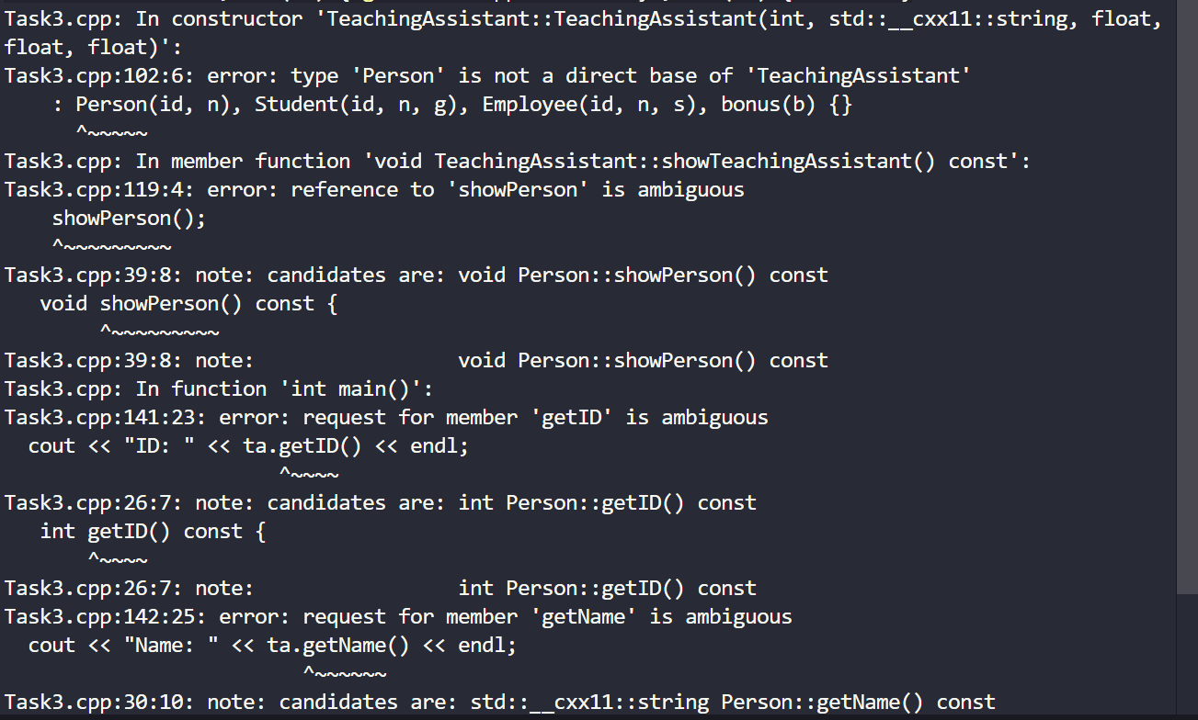

Output:
